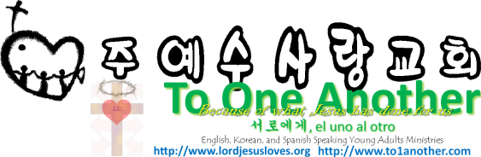
Purpose of Prayer
Pastor Yoo Nam Kang
Matthew 6:33
Scriptures in New Living Translation
February 10, 2013

Matthew 6:33
Seek the Kingdom of God above all else, and live righteously, and he will give you everything you need.
John 21:15-17
15 After breakfast Jesus asked Simon Peter, “Simon son of John, do you love me more than these?” “Yes, Lord,” Peter replied, “you know I love you.” “Then feed my lambs,” Jesus told him. 16 Jesus repeated the question: “Simon son of John, do you love me?” “Yes, Lord,” Peter said, “you know I love you.” “Then take care of my sheep,” Jesus said. 17 A third time he asked him, “Simon son of John, do you love me?” Peter was hurt that Jesus asked the question a third time. He said, “Lord, you know everything. You know that I love you.” Jesus said, “Then feed my sheep.

1. Seek the kingdom of God and His will first
Matthew 6:33
Seek the Kingdom of God above all else, and live righteously, and he will give you everything you need.
Isaiah 56:7
I will bring them to my holy mountain of Jerusalem and will fill them with joy in my house of prayer. I will accept their burnt offerings and sacrifices, because my Temple will be called a house of prayer for all nations.

2. Pray to hear the voice of the Holy Spirit
John 14:26
But when the Father sends the Advocate as my representative—that is, the Holy Spirit—he will teach you everything and will remind you of everything I have told you.
Numbers 5:10-12
10 Each priest may keep all the sacred donations that he receives.” 11 And the Lord said to Moses, 12 “Give the following instructions to the people of Israel. “Suppose a man’s wife goes astray, and she is unfaithful to her husband
2Corinthians 4:16-17
16 That is why we never give up. Though our bodies are dying, our spirits are being renewed every day. 17 For our present troubles are small and won’t last very long. Yet they produce for us a glory that vastly outweighs them and will last forever!
Isaiah 56:7
I will bring them to my holy mountain of Jerusalem and will fill them with joy in my house of prayer. I will accept their burnt offerings and sacrifices, because my Temple will be called a house of prayer for all nations.
Luke 19:46
He said to them, “The Scriptures declare, ‘My Temple will be a house of prayer,’ but you have turned it into a den of thieves.”

3. What allows us to receive answers to our prayers?
Matthew 6:13-14
13 And don’t let us yield to temptation, but rescue us from the evil one. 14 “If you forgive those who sin against you, your heavenly Father will forgive you.
3John 1:2
Dear friend, I hope all is well with you and that you are as healthy in body as you are strong in spirit.
1Timothy 4:5, 7-8
5 For we know it is made acceptable by the word of God and prayer. 7 Do not waste time arguing over godless ideas and old wives’ tales. Instead, train yourself to be godly. 8 “Physical training is good, but training for godliness is much better, promising benefits in this life and in the life to come.”

